Certainly! [In a nutshell, a **panel** can refer to a **flat or curved component** set into a surface (such as a door, wall, or ceiling), a **control board** with devices for operating machinery, or even a **small group of people** convened to discuss, advise, or make decisions1](https://bing.com/search?q=panel+definition)[2](https://dictionary.cambridge.org/dictionary/english/panel).

Here are **five free online learning resources** where you can expand your knowledge and skills:

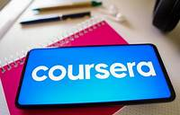

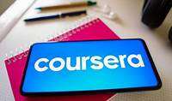

1. [**Coursera**](https://www.coursera.org/courses?query=free): Offers a wide range of courses, including Python programming, data analysis, and more. You can learn from top instructors and earn certificates.





1. [**Khan Academy**](https://www.khanacademy.org/): Provides free education in various subjects, from math to history, and is accessible to learners of all ages.





1. **Project Gutenberg**: Explore a vast collection of free eBooks, perfect for expanding your horizons through reading.

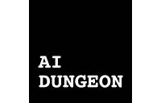

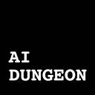

1. **AI4ALL Open Learning**: Empowers high school teachers to bring AI education to their classrooms with a free, adaptable AI curriculum.
2. **YouTube Learn at Home**: Discover educational channels and tutorials covering a wide range of topics.

Feel free to explore these resources and enhance your learning journey! 🌟📚